09th August 2016

**FIA WTCC “Pechito” Lopez extends lead at home race**

The FIA World Touring Car Championship, with the Japanese premium tyre manufacturer YOKOHAMA as exclusive tyre supplier visited Argentina at the weekend. This was the first race of the Championship away from Europe and initiates the final part of the season with races also scheduled in Japan, China, Thailand and Qatar.

Race 1 in Argentina was exciting and proved a very dynamic duel. Tom Chilton achieved a superb first victory for the Sebastien Loeb Racing in the FIA World Touring Car Championship, whilst the current Champion and local favourite, Citroen’s Jose Maria Lopez also gave cause for celebration to the many fans who attended to cheer on their hero. Lopez managed to get into the points with a meritorious fifth position from 18th on the starting grid, having been relegated to the back, due to a penalty as a result of an engine change.

Chilton and Honda driver Tiago Monteiro made great starts to the race from second and third on the grid and passing pole-man John Filippi before turn 1. The battle ensued within the three who took alternatives and some real bumper to bumper action.

Chilton managed a lead with a couple of seconds gap from Filippi who then also lost his place to Rob Huff on the seventh lap. Yvan Muller then also appeared on the scene from behind and caught up with the leading pack to eventually follow in third behind Huff and Chilton, who held on to win by 0.7 seconds.

Race 2 was also exciting and Jose Maria Lopez claimed another home victory, battling past Norbert Michelisz who had a good start and led early on. Yvan Muller was also in the thick of the action and was Lopez’s biggest ally as the ferocious competition between the Frenchman and the Hungarian, resulted in a contact that made them both slip back benefitting Lopez who squeezed through to extend his overall Championship lead.

For his part Tom Coronel, who later claimed he had enjoyed the best VIP seat at the “Termas” Autodrome, from a safe distance, took the opportunity of the contact between Muller and Michelisz to take a sweet and unexpected second place and Rob Huff again, reaching the podium in third place.

Tiago Monteiro followed in fourth and Muller claimed a tough fifth ahead of Argentinian debutant Esteban Guerrieri, who recovered from a bad start to take a credible sixth place and making a statement of intentions and hoping for a full-time drive in the WTCC next season.

The next race will be held in Japan on the 3rd & 4th September.

Current Overall standings:

JM Lopez 284pts

T Monteiro 167pts

Y Muller 160pts

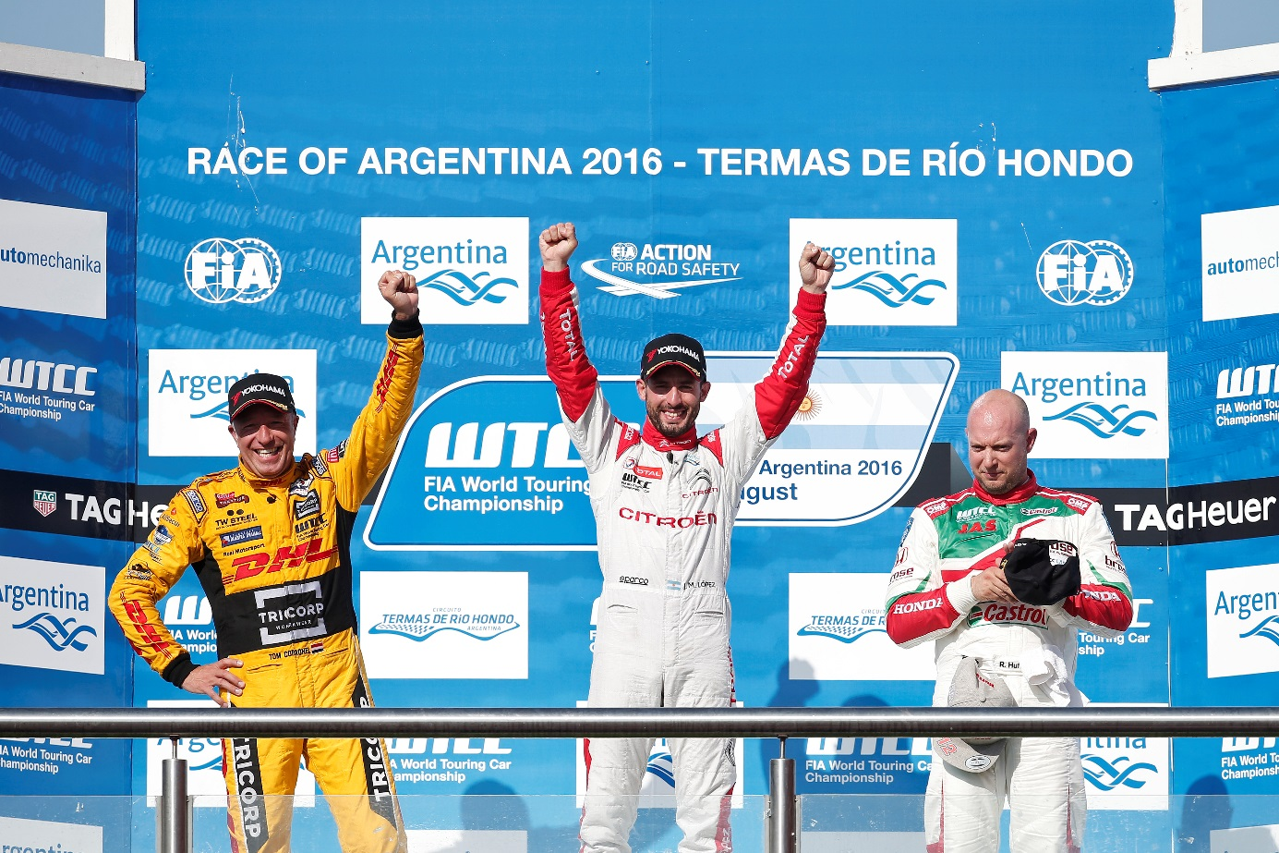

*Pechito Lopez wins Race 2 in Argentina*

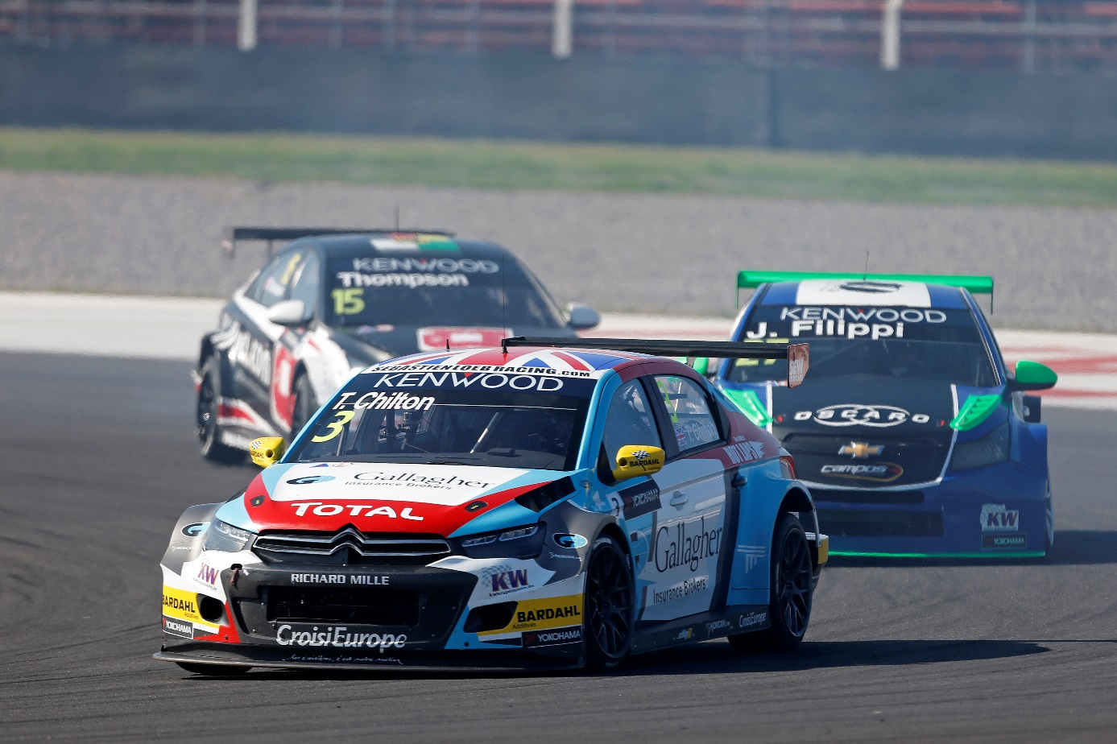

*Tom Chilton wins opening race at WTCC Argentina*